|  |
| --- |
| **A**  **PROJECT REPORT ON** |
|  |
|  |
| Second Opinion |
|  |
|  |
| SUBMITTED IN  PARTIAL FULFILLMENT OF  **DIPLOMA IN ADVANCED COMPUTING (PG-DAC)** |
|  |
|  |
|  |
|  |
|  |
|  |
|  |
| **BY**  **Kritagya Chopra**  **Ritu Powar**  **Ujjwal Pratap Singh** |
|  |
|  |
| **UNDER THE GUIDENCE OF**  **<GUIDE NAME>** |
|  |
|  |
|  |
| **AT**  **SUNBEAM INSTITUTE OF INFORMATION TECHNOLOGY,**  **PUNE** |

|  |  |
| --- | --- |
|  | |
| **SUNBEAM INSTITUTE OF INFORMATION TECHNOLOGY,**  **PUNE.** | |
|  | |
|  | |
|  | |
|  | |
| **CERTIFICATE** | |
|  | |
| This is to certify that the project | |
|  | |
| Second Opinion | |
|  | |
| Has been submitted by | |
|  | |
| **Ritu Powar** | |
|  | |
|  | |
| In partial fulfillment of the requirement for the Course of **PG Diploma in Advanced Computing (PG-DAC AUG2015)** as prescribed by The **CDAC** ACTS, PUNE. | |
|  | |
|  | |
| Place: Pune | Date: 19-FEB-2024 |
|  | |
|  | |
|  | |
|  | |
|  | |
| **<Project Guide Name>** | **<Alumni Mentor Name>** |
| **Project Guide** | **Alumni Mentor** |

**ACKNOWLEDGEMENT**

We would like to extend our sincere gratitude to all those who contributed to the completion of this project. Firstly, we would like to express our deepest appreciation to our project supervisor, [Supervisor's Name], for their invaluable guidance, unwavering support, and insightful feedback throughout the duration of this project. Their expertise and encouragement were instrumental in shaping the direction of our work.

We are also grateful to our project team for their dedication, hard work, and collaborative spirit, which greatly contributed to the success of this project. Their creativity, enthusiasm, and commitment were indispensable in overcoming challenges and achieving our goals.

Furthermore, we would like to acknowledge the support and cooperation received from Sunbeam, without which this project would not have been possible.

Additionally, we appreciate the valuable feedback and suggestions received from Sunbeam Institute and other individuals who provided insights that helped improve the quality of our work. Their unwavering support sustained us during challenging times and made this project possible.

Thank you to everyone who contributed to the success of this project. Your support and encouragement are deeply appreciated.

**ABSTRACT**

Our project empowers users to seek a second opinion on their medical treatment by connecting them with leading medical specialists. We prioritize providing individuals with valuable insights and expert perspectives to ensure informed decisions about their healthcare journey.

**INDEX**

|  |  |  |
| --- | --- | --- |
|  | **INTRODUCTION** | 1 |
|  | 1.1 Introduction | 1 |
|  | **Project Overview and Summary** |  |
|  | 2.1 Purpose | 2 |
|  | 2.2 Scope | 3 |
|  | 2.3 User Classes and Characteristics |  |
|  | 2.4 Design and Implementation Constraints | 4 |
|  | **REQUIREMENTS** |  |
|  | 3.1 Functional Requirements |  |
|  | 3.1.1 Use case for Administrator. |  |
|  | 3.1.2 Use case for Customer. |  |
|  | 3.2 Non - Functional Requirements |  |
|  | 3.2.1 Usability Requirement |  |
|  | 3.2.2 Performance Requirement |  |
|  | 3.2.3 Reliability Requirement |  |
|  | 3.2.4 Portability Requirement |  |
|  | 3.2.5 Security Techniques |  |
|  | **PROJECT DESIGN** |  |
|  | 4.1 Data Model |  |
|  | 4.1.1 Database Design |  |
|  | 4.2 Process Model |  |
|  | 4.2.1 Functional Decomposition Diagram |  |
|  | 4.2.2 Data Flow Diagram (DFD) |  |
|  | **TEST REPORT** |  |
|  | **PROJECT RELATED STATISTICS** |  |
|  | **CONCLUSION** |  |

**LIST OF TABLES**

|  |  |  |
| --- | --- | --- |
| **Section** | **Table Title** | **Page** |
|  |  |  |
|  |  |  |
|  |  |  |
|  |  |  |
|  |  |  |
|  |  |  |

**LIST OF FIGURES**

|  |  |  |
| --- | --- | --- |
| **Section** | **Figure Title** | **Page** |
|  |  |  |
|  |  |  |
|  |  |  |
|  |  |  |
|  |  |  |
|  |  |  |
|  |  |  |
|  |  |  |
|  |  |  |
|  |  |  |
|  |  |  |
|  |  |  |

**INTRODUCTION**

The Second Opinion Platform is an innovative solution designed to connect users with qualified doctors and specialists for consultations on medical operations or treatments. In the rapidly evolving healthcare landscape, seeking a second opinion is becoming increasingly important for patients to ensure they receive accurate diagnoses and appropriate treatment plans. This platform aims to facilitate this process by providing users with easy access to expert medical advice from the comfort of their homes.

**PURPOSE**

The primary purpose of the Second Opinion Platform is to empower users to make informed healthcare decisions by offering them access to a network of experienced doctors and specialists. Whether they are facing a complex medical condition, considering surgery, or exploring alternative treatment options, users can seek additional perspectives and insights from trusted medical professionals through this platform. By bridging the gap between patients and doctors, the platform aims to improve healthcare outcomes and enhance patient satisfaction.

**SCOPE**

**Key Features:**

1. User Registration and Profile Creation: Allows users to create accounts and build profiles with relevant medical history and information.
2. Doctor Search and Selection: Enables users to search for doctors based on specialty, experience, and availability, and select the most suitable healthcare provider for their needs.
3. Consultation Booking: Facilitates the booking of virtual consultations with chosen doctors, allowing users to schedule appointments at their convenience.
4. Secure Communication: Provides a secure and confidential platform for users to communicate with doctors, share medical records, and discuss their concerns.
5. Second Opinion Services: Offers users the opportunity to seek second opinions on medical diagnoses, treatment plans, surgical procedures, and other healthcare-related matters.
6. File Management: Allows users to upload and manage medical documents, test results, and imaging studies for review by doctors.
7. Payment Processing: Handles secure payment transactions for consultation fees and other services provided by doctors.
8. Feedback and Rating System: Enables users to provide feedback and ratings based on their experience with doctors, helping to maintain quality standards and accountability.

**Benefits:**

* Access to Expertise: Provides users with access to a diverse network of qualified doctors and specialists from various medical fields.
* Convenience and Flexibility: Allows users to seek medical advice from anywhere, anytime, using their computer or mobile device.
* Confidence and Peace of Mind: Empowers users to make well-informed healthcare decisions by obtaining multiple perspectives and opinions.
* Reduced Wait Times: Minimizes the time spent waiting for appointments and traveling to healthcare facilities, leading to faster resolution of medical concerns.
* Privacy and Confidentiality: Ensures the privacy and confidentiality of user information and medical records through robust security measures.

**FUNCTIONAL REQUIREMENTS**

1. User Registration and Authentication:

- Users should be able to create accounts securely.

- A secure authentication mechanism to protect user data.

2. User Profile:

- Users should be able to create and manage their profiles.

- Profile information may include personal details, medical history, and preferences.

3. Symptom:

- A symptom tool to allow users to input their symptoms.

- The system should provide potential diagnoses based on the symptoms entered.

4. Medical History:

- Capability for users to input and manage their health information, including medications, allergies, and medical history.

- Secure storage and access control for sensitive health data.

5. Telemedicine Integration:

- Integration with telemedicine services for virtual consultations.

- Secure and private video/audio communication.

6. Diagnostic Tests Tracking:

- Ability for users to track and manage their diagnostic tests.

- Integration with laboratories and healthcare providers for test results.

7. Health Recommendations:

- Provide personalized health recommendations based on user profiles and medical history.

8. Feedback and Rating System:

- Users should be able to provide feedback and ratings for healthcare professionals and services.

9. Educational Resources:

- Integration of educational materials related to health and specific conditions.

10. Privacy and Security:

- Compliance with data protection regulations.

- Secure data transmission and storage practices.

11. Search and Filter Functionality:

- Efficient search and filter options for finding healthcare professionals all over the world.

12. User Support:

- Provide a support system for users to get assistance with technical issues or general inquiries.

**PROJECT DESIGN**

**USE CASE DIAGRAM**

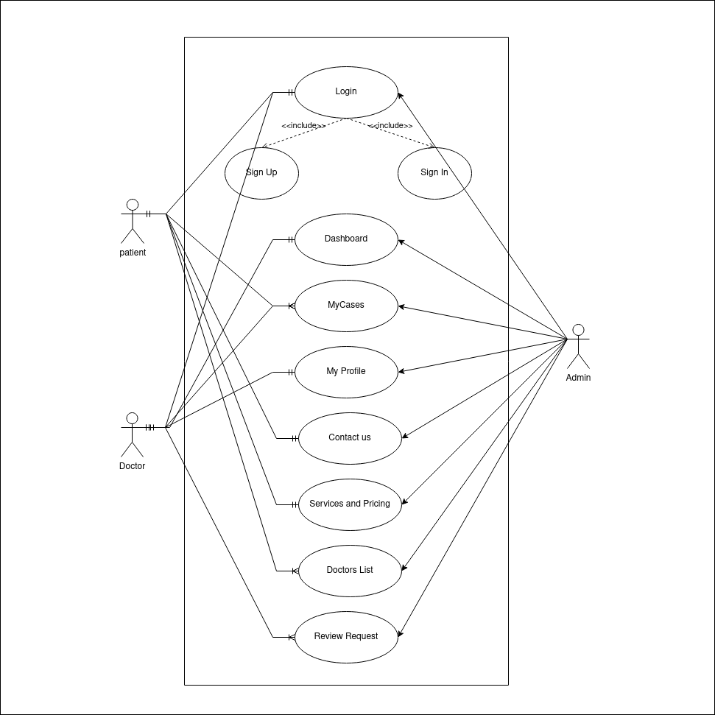

**ENTITY-RELATION DIAGRAM**

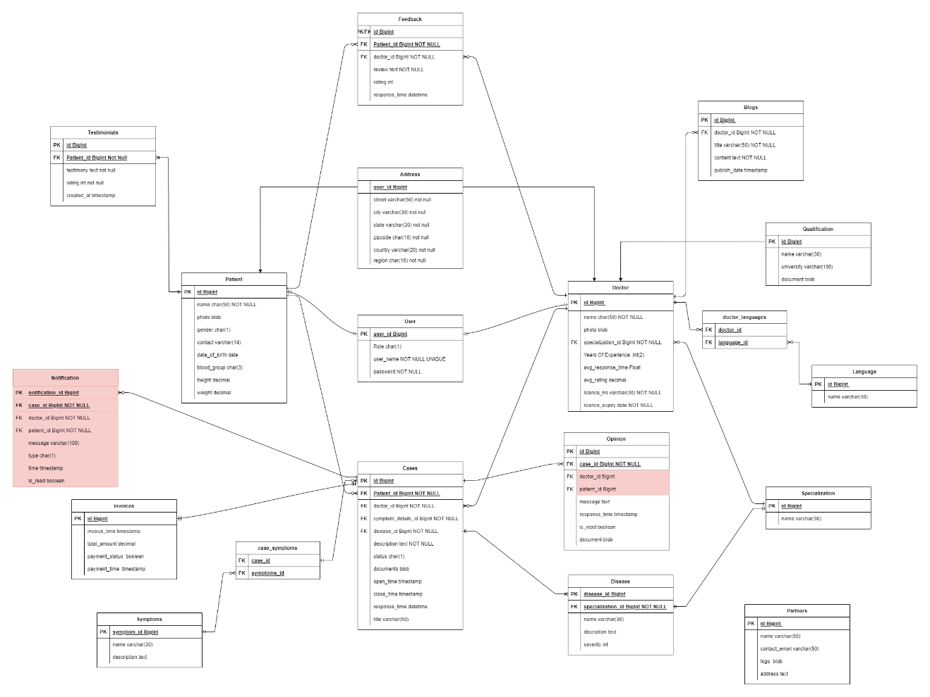

**CONCLUSION**

The Second Opinion Platform represents a significant advancement in patient-centered healthcare, offering users greater control and autonomy over their healthcare journeys. By leveraging technology to connect users with expert medical advice, the platform aims to promote transparency, collaboration, and empowerment in healthcare decision-making, ultimately leading to improved health outcomes and patient satisfaction.